- PARSONAL DETAILES

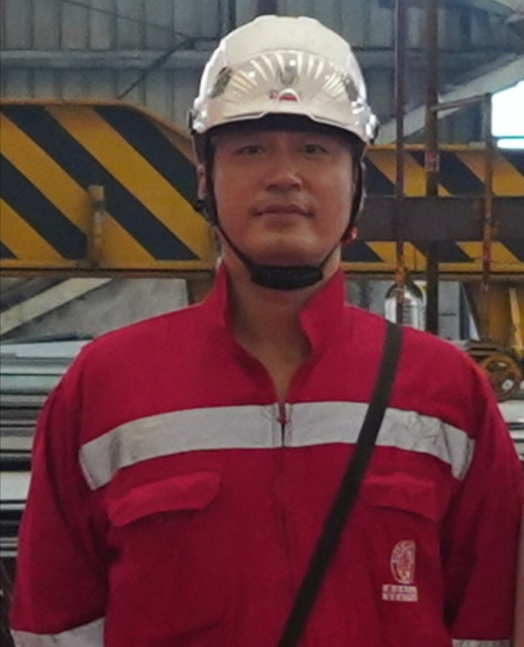
Full Name : | Wayne Zheng
Date of Birth : | Oct.24,1988
Nationality : | China
Marital Status : | Married
Language : | Chinese

2. EDUCATION

Dalian University of Technology（Bachelor）

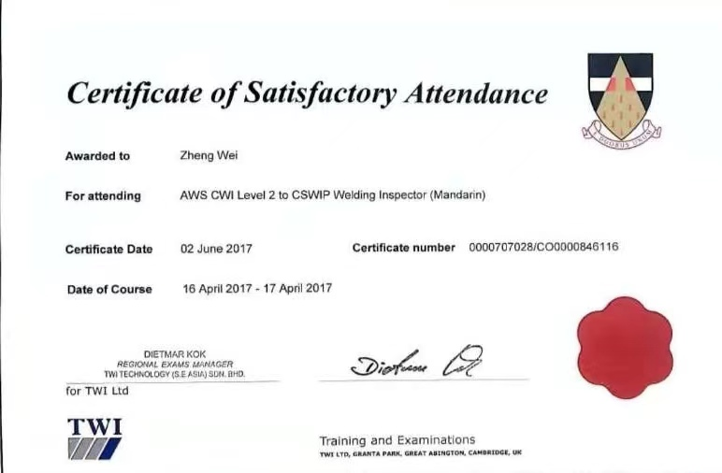
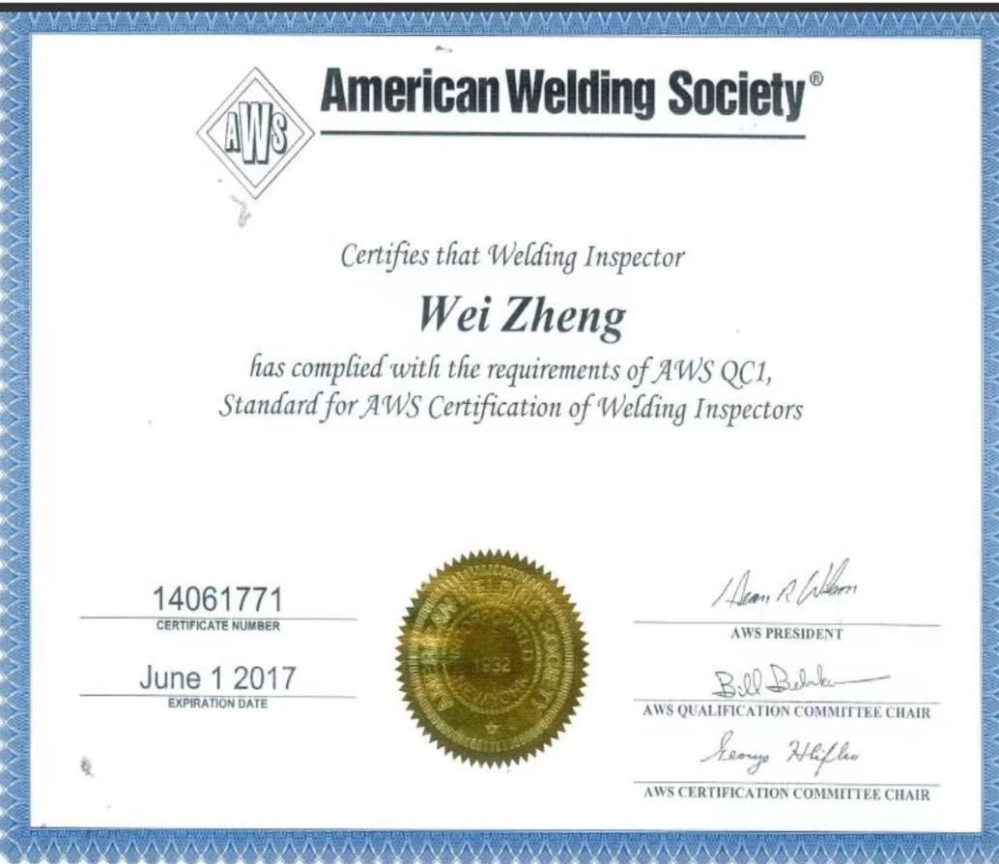
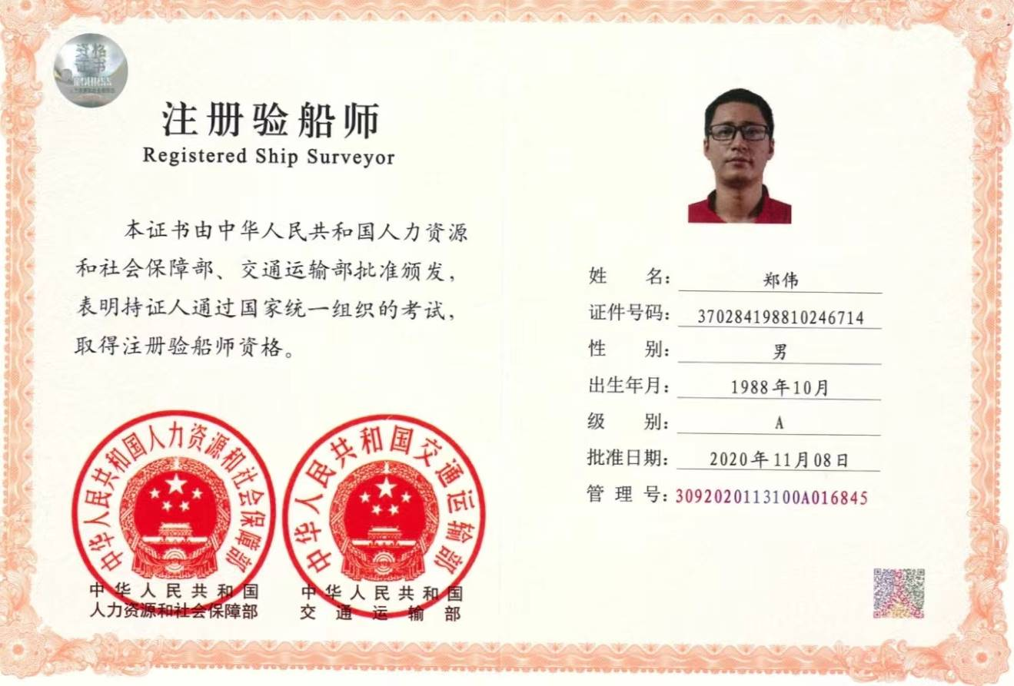
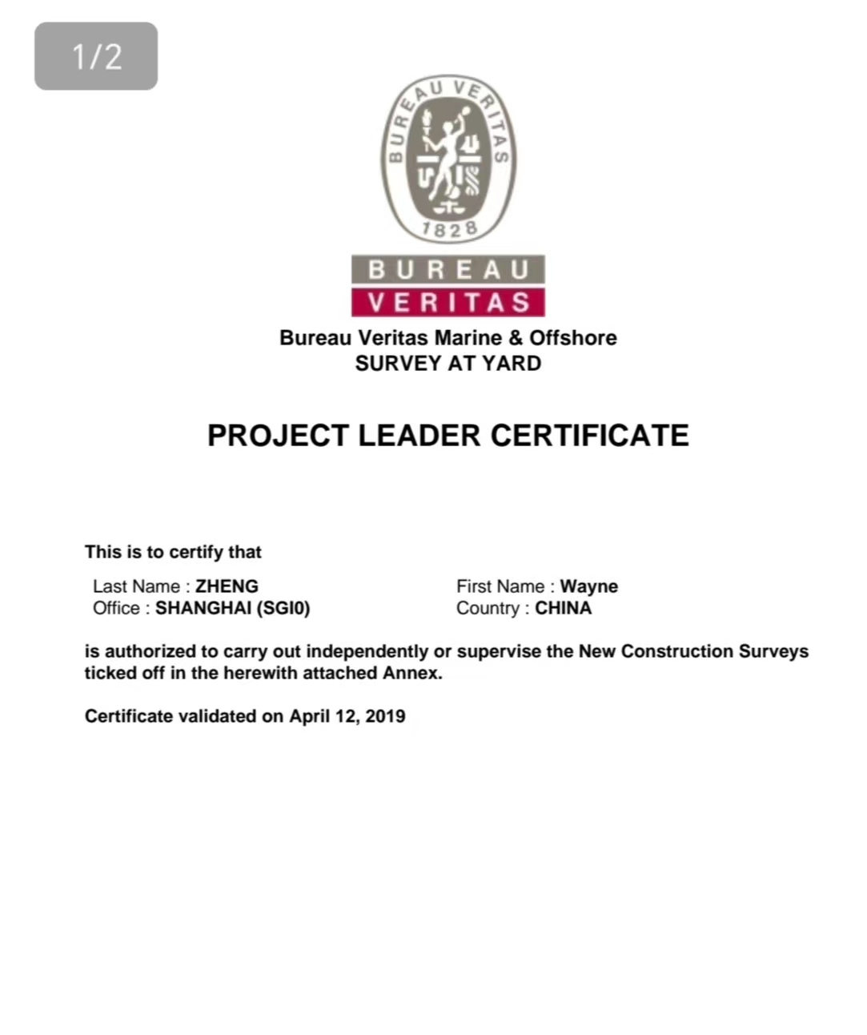
3. QUALIFICATIONS

Month / Year  11/2024  07/2024  07/2024  07/2024  04/2023  10/2022  06/2021  05/2021  11/2020  04/2019  05/2016  06/2017 | Description  IHM  Updating for PL  AUT  Ballast Water Management（BWM）  Steel 2（Assembly material advanced）  Hazardous area and explosion proof equipment  SPS （Special purpose ship）  PSSC (Statutory Passenger Ship Safety)  MSA Certificate  Project Leader Certificate  Level 2 SAY Certificate  CSWIP Certificate
02/2016  05/2014 | Level 1 SAY Certificate  AWS CWI Level-2 Certificate
10/2008 | Senior CAD
4. TRAINING BEFORE AND AFTER JOINED WITH BV RELATED WITH CERTIFICATION

Training designation | Organised | Date | Duration (Months) | Training Course Description
OLAW Practice | BV  online | 28/05/2026 | 1 day | 1.Installation survey (covering foundation/pedestal positioning, welding and NDE);  2.Lifting appliances load test  3.Lifting appliances operational and safety survey
OLAW Theoretical | BV  online | 10/10/2025 | 1 day | OLAW Training
IHM Practical | BV  Shanghai | 11/2024 | 1 month | - Inventory of Hazardous Material  - Documentation - Check the IHM company qualified certificate  - Documentation - Check the IHM test laboratory certificate  - Documentation - IHM on board sampling survey by expert company  - Documentation - Shipyard collection IHM documents reports
IHM Theoretical | BV  Shanghai | 21/11/2024  -  22/11/2024 | 2 days | - Survey and certificate  - G34-TU01/02/03/04
AUT  Practical | BV  Shanghai | 05/2024  -  06/2024 | 1 months | - Review of Onboard test and Sea trial AUT - UMS procedures accordance with Rules.  - Confirmation of the Alarm setting and testing, checking of alarm function  - Confirmation test of Safety Devices at sea trial  - Sea Trial AUT - UMS Test of operating conditions, including manoeuvring, of the whole machinery in an unattended situation for 6 hr.
AUT  Theoretical | BV  Shanghai | 11/04/2024  -  12/04/2024 | 2 days | - Introduction  - Automation system general requirements  - Additional class notation  - Test on board
PL  Theoretical | BV  Shanghai | 12/03/2024  -  14/03/2024 | 2 days | - surveyor role as per PNC16.  - Project leader role as per PNC16.  - Project in phase  - Communication with the team  - Witness or Patrolling  - Technical issues  - Project record  - Project documentation
BWMS Practical | BV  Shanghai | 10/01/2024  -  08/07/2024 | 6 months | -Piping installation survey and witness leak/hydraulic tests of the piping in accordance with the requirements given in Pt C Ch 1 Sec 10 and IACS UR M74.  -BI 1.1.2.3 and BI 1.1.2.12: Verify the conditions given in the IMO G8 TAC of the BWMS issued by the Administration and that the IMO G8 TAC is available onboard.
BWMS Theoretical | BV  Shanghai | 10/01/2024  -  24/05/2024 | 5 months | G23a-BWM Regulatory aspects and technologies.  G23b-BWM Survey and cetification
Steel 2  Advanced | BV  Shanghai | 11/04/2023  -  15/04/2023 | 6 days | -Welding patrol survey  -Witness welding test  -WPS approval
Hazardous area | BV  Shanghai | 22/12/2022  -  28/12/2022 | 6 days | -Dangerous area classification  -Dangerous material characteristics
PSSC Theoretical Training | BV  Shanghai | 15/02/2021  -  23/02/2021 | 7 days | -Fire Prevention and Life-saving  -Polar code  -SPS code  -SRTP(safety return to port)  -Port States (Incl. USCG and EMSA)
PSPC Practical Training  (NC 09) | BV Shanghai | 28/11/2016  -  09/12/2016 | 14 days | -Document Check  TAC and TDS  -Document Review  Coating technical file  -Site survey
VDGB Training | BV Shanghai | 29/11/2016 | 1 days | -Technical training  -Focus on SOLAS II- 2 Reg.  -How does VDGB configurator work
NC Level 2 SAY Certificate | BV Shanghai | 27/11/2015  -  3/6/2016 | 6 months | -NC2 Assembly material advanced  -NC3 Machinery and Electricity advanced  -NC5 Statutory
PSPC Theoretical | BV Shanghai | 23/05/2016  - 25/05/2016 | 3 days | -PSPC introduction  -Coating system and Inspection  - PSPC Statutory Regulation  - PSPC verification  - Coating system approval
MED | BV Shanghai | 25/05/2016 | 1 days | -General Provisions  -Manufacturers
NC Level I SAY certificate | BV Shanghai | 13/11/2015  -  23/2/2016 | 3 months | -NC1 Practical training
NC Level II Training | BV Shanghai | 17/11/2015 – 22/11/2015 | 6 days | -NC2, NC3, NC5, NC6 theoretical
NC Level I Training | BV Shanghai | 3/11/2015  -  14/11/2015 | 12 days | -NC1 Theoretical training
CWI | AWS | 05/05/2014  -  10/05/2014 | One week | -Welding inspection technology
Senior CAD | Chinese industry and Education department | 06/2008  -  07/2008 | One month | -CAD design and drawing

5. WORK EXPERIENCE BEFORE AND AFTER JOINED WITH BV

Period : 09/09/2014-Present
Position : NC Surveyor of Bureau Veritas
Job Description : New Construction survey

Period : | 05/2014 up to 09/2014
Position : | QA/QC inspector of Mcdermott Wuchuan
Job Description : | Off-shore Platform survey

Period : | 01/12/2012 – 30/4/2014
Position : | QA/QC inspector of Qingdao YangFan shipyard
Job Description : | New shipbuilding survey

Period : | Feb.2009 – Nov.2012
Position : | QC inspector of Qingdao Hyundai shipyard
Job Description : | New shipbuilding survey

. DETAIL EXPERIENCE ON NC SURVEYS IN BUREAU VERITAS :
Hull+ Piping+  Mach.+ Elec.+ Statutory Survey | Starbulk | 46099K | 82K DWT Bulk Carrier | CMI Qingdao Shipyard | 16/07/2025  -  Till now | PLD/ Surveyor
Hull+ Piping+  Mach.+ Elec.+ Statutory Survey | Cosmoship | 46743L | 82K DWT Bulk Carrier | CMI Qingdao Shipyard | 15/01/2025  -  Till now | Surveyor
Hull+ Piping+  Mach.+ Elec.+ Statutory Survey | Lavina | 46665A | 82K DWT Bulk Carrier | CMI Qingdao Shipyard | 04/11/2024  -  Till now | Surveyor
Hull+ Piping+  Mach.+ Elec.+ Statutory Survey | Lavina | 46664Y | 82K DWT Bulk Carrier | CMI Qingdao Shipyard | 04/11/2024  -  Till now | Surveyor
Hull+ Piping+  Mach.+ Elec.+ Statutory Survey | Starbulk | 46096G | 82K DWT Bulk Carrier82K DWT Bulk Carrier | CMI Qingdao Shipyard | 06/08/2024  -  Till now | Surveyor
Hull+ Piping+  Mach.+ Elec.+ Statutory Survey | Starbulk | 46095F | 82K DWT Bulk Carrier | CMI Qingdao Shipyard | 06/08/2024  -  Till now | PLD/ Surveyor
Hull+ Piping+  Mach.+ Elec.+ Statutory Survey | PRESIDENT GRANT | 41512Y | 5500TEU Container Vessel | CSSC Qingdao Beihai | 06/05/2023  -  06/08/2024 | Surveyor
Hull+ Piping+  Mach.+ Elec.+ Statutory Survey | PRESIDENT GRANT | 41505R | 5500TEU Container Vessel | CSSC Qingdao Beihai | 06/05/2023  -  06/05/2024 | Surveyor
Hull+ Piping+  Mach.+ Elec.+ Statutory Survey | PRESIDENT REAGAN | 41506S | 5500TEU Container Vessel | CSSC Qingdao Beihai | 01/08/2023  -  06/06/2024 | Surveyor
Hull+ Piping+  Mach.+ Elec.+ Statutory Survey | PRESIDENT HW BUSH | 41507T | 5500TEU Container Vessel | CSSC Qingdao Beihai | 25/10/2023  -  22/07/2024 | PL
Hull+ Piping+  Mach.+ Elec.+ Statutory Survey | PRESIDENT MONROE | 41508U | 5500TEU Container Vessel | CSSC Qingdao Beihai | 15/12/2022  -  06/08/2024 | Surveyor
Hull+ Piping+  Mach.+ Elec.+ Statutory Survey | PRESIDENT LB JOHNSON | 41509V | 5500TEU Container Vessel | CSSC Qingdao Beihai | 29/12/2023  -  06/08/2024 | Surveyor
Hull+ Piping+  Mach.+ Elec.+ Statutory Survey | CMA CGM SILVER FERN | 41510W | 5500TEU Container Vessel | CSSC Qingdao Beihai | 10/05/2023  -  06/08/2024 | Surveyor
Hull+ Piping+  Mach.+ Elec.+ Statutory Survey | CMA CGM KAURI | 41511X | 5500TEU Container Vessel | CSSC Qingdao Beihai | 10/05/2023  -  06/08/2024 | Surveyor
Hull+ Piping+  Mach.+ Elec.+ Statutory Survey | CMA CGM OUVEA | 41512Y | 5500TEU Container Vessel | CSSC Qingdao Beihai | 20/07/2023  -  06/08/2024 | Surveyor
Hull+ Piping+  Mach.+ Elec.+ Statutory Survey | CMA CGM TIGA | 41513A | 5500TEU Container Vessel | CSSC Qingdao Beihai | 17/11/2023  -  06/08/2024 | Surveyor
Hull+ Piping+  Mach.+ Elec.+ Statutory Survey | PRESIDENT JQ ADAMS | 41504Q | 5500TEU Container Vessel | CSSC Qingdao Beihai | 28/11/2022  -  01/02/2024 | Surveyor
Hull+Mach.+elec.+ Statutory Survey | MR | 30677W | 49.2K DWT Oil-Chemical | Jing Lu | 03/2022 | Surveyor
Hull+Mach.+elec. | Dynacom | 38896C | 163KDWT COT | NTS | 10/2021 | Surveyor
Hull+Mach.+elec | Sunstone | 38294B | Expedition Cruise vessel | CMHI | 05/2020 | Surveyor
Hull+Mach.+elec. | CMA CGM | 34638C | 3300TEU  Container Vessel | Hudong | 05/2019 | Surveyor
Hull+Mach.+elec | CMA CGM | 30260T | 3300TEU  Container Vessel | COSCO | 05/2017 | Surveyor
Hull+Mach.+elec | CARDIFF | 29834F | 158KDWT COT | SWS | 03/2016 | Surveyor
Hull+Mach.+elec | Ocean Bulk | 27802W | 208K DWT Bulk Carrier | SWS | 04/2015 | Surveyor
Hull | BGT | 25144H | LNG ship | SamSung | 09/2014 | Surveyor

